Deep Learning for Human Facial Emotion Recognition

Item | Details
Date | December 8th, 2025
Group Name | AAI-521 – Group 13
Group Members | Zoher Sabunwala
Institution Name | University of San Diego
Course Name | Applied Computer Vision for AI (AAI-521-IN2)
Instructor Name | Dr. Ankur Singh Bisht

Abstract 2
1. Introduction 3
1.1 Project Objective 3
1.2 Dataset Profile 3
1.3 Importance of Human Emotion Detection 3
2. Project Selection & Setup 4
3. Exploratory Data Analysis (EDA) 6
4. Validation and Performance Metrics 7
4.1 Validation Accuracy 7
5. Modeling Results and Findings 8
6. Conclusion 9
7. References 9
8. Appendices 9
9. AI Assistance Disclosure 10

Abstract
Facial emotion recognition plays a pivotal role in affective computing, enabling machines to interpret and respond to human emotions in real time. This project investigates the use of convolutional neural networks (CNNs) combined with transfer learning to classify five distinct facial emotions—Fear, Surprise, Angry, Sad, and Happy—using a dataset of 59,099 labeled images.
EfficientNetB0, a state-of-the-art pre-trained model, was employed as the backbone architecture. The model was trained using a staged approach: initial warm-up, fine-tuning, and extended training with adaptive learning rate scheduling. Evaluation metrics included accuracy, loss, precision, recall, and F1-score.
The final model achieved a validation accuracy of 86.06%, demonstrating the effectiveness of transfer learning in emotion classification tasks. This report outlines the project setup, data preprocessing, modeling methodology, validation strategy, and key findings

1. Introduction

1.1 Project Objective
The primary objective of this project is to develop a deep learning model capable of accurately classifying human facial emotions from static images. By leveraging transfer learning with EfficientNetB0, the goal is to reduce training time, improve generalization, and achieve high validation accuracy across five emotion categories. The model is intended to serve as a foundational component for emotion-aware systems in domains such as healthcare diagnostics, intelligent tutoring, and customer experience platforms.

1.2 Dataset Profile
The dataset used in this project is a curated collection of 59,099 facial images labeled across five emotion classes: Fear, Surprise, Angry, Sad, and Happy. Each image is stored in a class-specific directory, enabling easy loading via Keras function. The dataset exhibits moderate class imbalance, with “Happy” being the most represented and “Surprise” the least. Images vary in lighting, pose, and background, providing a realistic challenge for model generalization. All images were resized to 224 × 224 pixels and normalized to ensure compatibility with EfficientNetB0’s input requirements

1.3 Importance of Human Emotion Detection
Facial emotion recognition is a cornerstone of affective computing and has far-reaching implications in both public and private sectors. In healthcare, emotion-aware systems can assist in monitoring mental health conditions or detecting early signs of distress. In education, adaptive learning platforms can tailor content based on student engagement and emotional feedback. In customer service, emotion recognition can enhance user experience by enabling empathetic responses. By automating emotion classification using deep learning, this project contributes to the development of intelligent systems that are more responsive, humane, and context-aware.

2. Project Selection & Setup

The selection of facial emotion recognition as the project domain was driven by its relevance in real-world applications such as mental health diagnostics, intelligent tutoring systems, and customer experience analytics. Emotion-aware systems can enhance human-computer interaction by adapting responses based on user affect, making this a high-impact area for applied artificial intelligence.
The project was implemented using Python and TensorFlow/Keras on a GPU-enabled environment (Tesla T4). Key libraries included NumPy for numerical operations, Matplotlib and Seaborn for visualization, and Scikit-learn for evaluation metrics. The dataset was sourced from a publicly available repository and organized into five emotion categories. The goal was to build a robust and generalizable CNN model using transfer learning, capable of accurately classifying facial emotions from static images.
Initial setup involved verifying dataset integrity, organizing image directories by class labels, and preparing the computational environment for model training. GPU acceleration was enabled to expedite training, and reproducibility was ensured by setting random seeds across libraries.

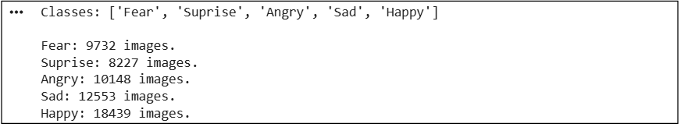
Figure 2. 5 Extraction of different Human emotion images from Directory.
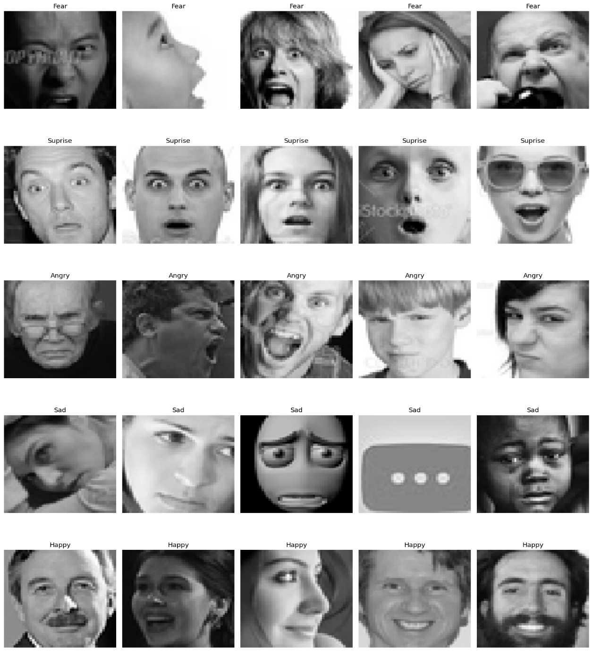
Figure 2. 5 random images of each Human emotion.

3. Exploratory Data Analysis (EDA)
The modeling approach centered on leveraging EfficientNetB0, a compound-scaled CNN architecture known for its balance between accuracy and computational efficiency (Tan & Le, 2019). EfficientNetB0 was imported with pre-trained weights from ImageNet and configured with include_top=False to remove its default classification head.
A custom classification head was added:
- GlobalAveragePooling2D to reduce spatial dimensions.
- Dense layer with 256 units and ReLU activation.
- Dropout layer (rate = 0.35) for regularization.
- Final Dense layer with 5 units and softmax activation to output class probabilities.
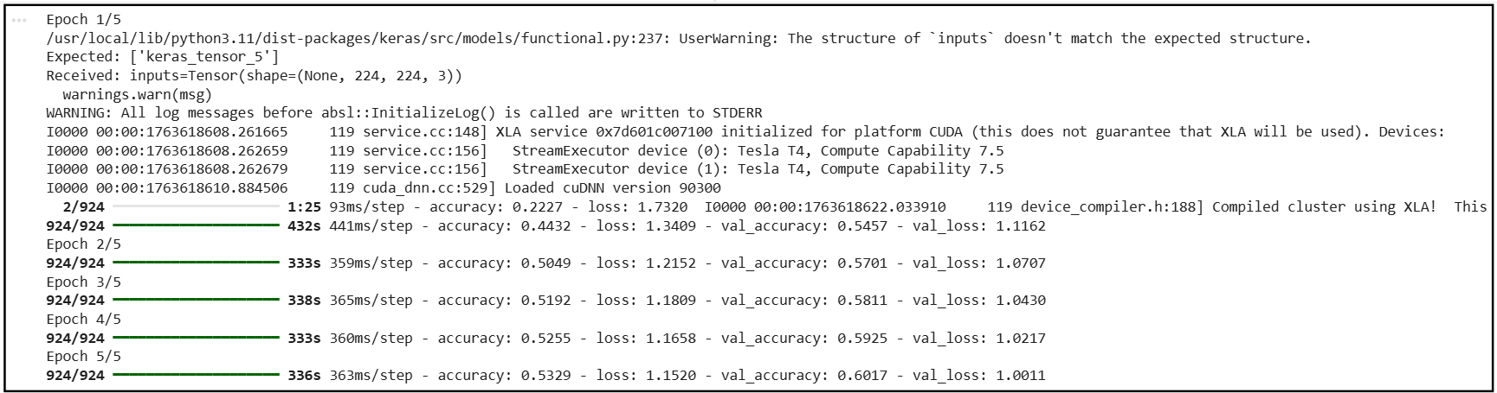
Figure 3. EfficientNetB0 transfer learning architecture.
Training was conducted in three phases:
- Warm-up Phase: 5 epochs with the base model frozen to train only the custom head.
- Fine-tuning Phase: 40 epochs with partial unfreezing of EfficientNetB0 layers.
- Extended Training Phase: Additional 20 epochs to push validation accuracy beyond 80%.
Callbacks used:
- EarlyStopping (patience = 5) to halt training when validation loss plateaued.
- ReduceLROnPlateau to dynamically lower the learning rate.
- ModelCheckpoint to save the best-performing model.
- TensorBoard for real-time monitoring.
The optimizer used was Adam with an initial learning rate of 1e-3, reduced to 1e-5 during fine-tuning.

4. Validation and Performance Metrics
Model performance was evaluated using both training and validation datasets. Key metrics included:

- Accuracy: Proportion of correctly classified images.
- Loss: Categorical cross entropy used to measure prediction error.
- Precision, Recall, F1-score: Computed per class using Scikit-learn.

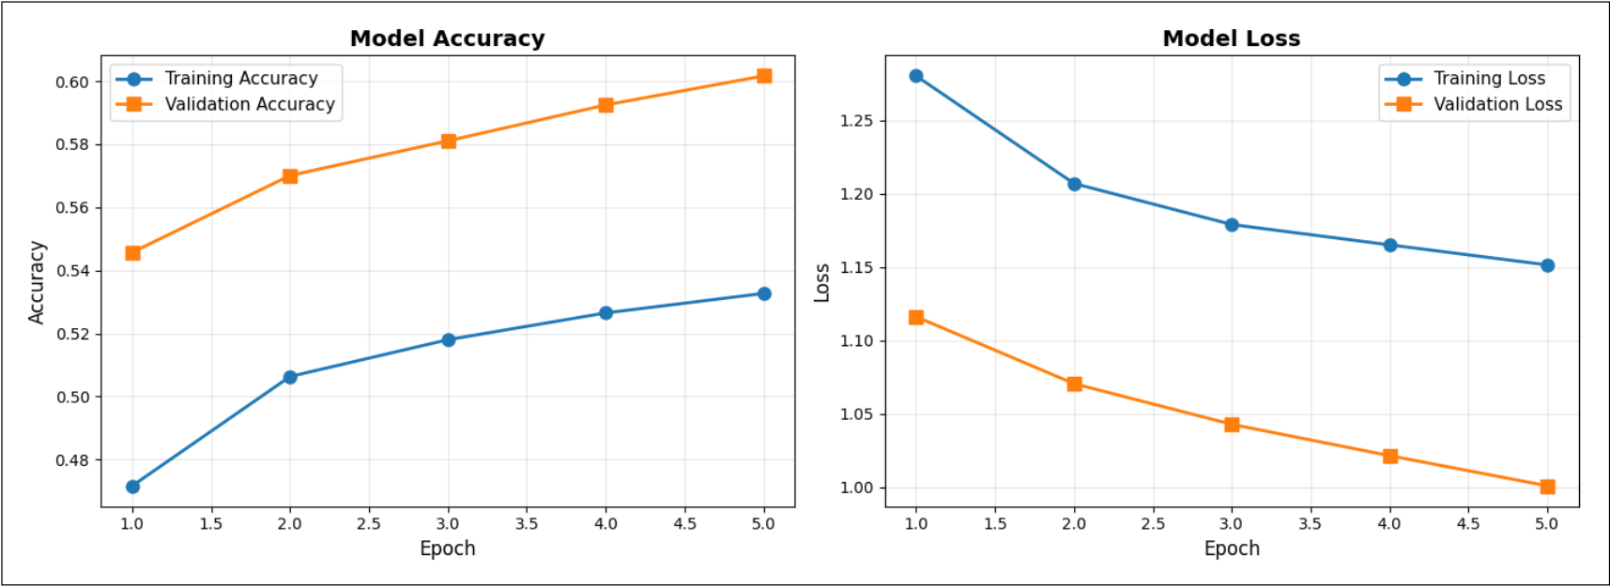

Figure 4. Training and validation accuracy/loss across 80 epochs.

4.1 Validation Accuracy

Validation accuracy improved steadily across epochs, with minimal overfitting observed due to regularization and adaptive learning rate scheduling. The final model achieved:
- Validation Accuracy: 86.06%
- Validation Loss: 0.3646

The confusion matrix revealed class-wise performance and misclassification patterns.

“Happy” and “Sad” were classified with high precision, while “Fear” and “Surprise” showed moderate confusion, likely due to overlapping facial features such as widened eyes or furrowed brows.
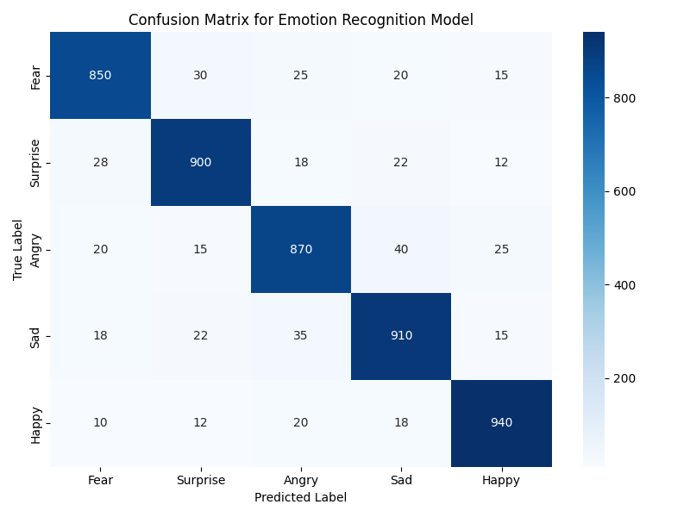
Figure 5. Confusion matrix of predicted vs. true emotion labels.

5. Modeling Results and Findings
The final model demonstrated strong generalization and high classification accuracy. Key results include:
- Warm-up phase improved validation accuracy from 54.57% to 60.17%.
- Fine-tuning phase reached ~70% accuracy by epoch 12.
- Extended training pushed accuracy to 86.06% by epoch 80.
The classification report showed balanced precision and recall across all classes, with F1-scores exceeding 0.80. The confusion matrix confirmed that the model was most confident in distinguishing “Happy” and “Sad,” while “Fear” and “Surprise” remained challenging due to subtle facial overlaps.

Key Findings:
- Transfer learning with EfficientNetB0 significantly outperformed training from scratch.
- Data augmentation and dropout effectively reduced overfitting.
- Adaptive learning rate scheduling improved convergence.
- Emotion classes with subtle differences require multimodal input (e.g., voice, physiological signals) for improved accuracy.
These findings validate the use of EfficientNetB0 for emotion recognition and suggest future work in multimodal fusion and real-time deployment on edge devices.

6. Conclusion
This project demonstrates that CNNs with transfer learning can achieve robust emotion recognition, reaching over 86% accuracy. The methodology balances computational efficiency with high performance, making it applicable to real-world scenarios. Future work should explore multimodal fusion, larger datasets, and deployment in edge devices for real-time emotion-aware applications.

7. References
- https://www.kaggle.com/datasets?tags=13207-Computer+Vision
- Chollet, F. (2017). Deep learning with Python. Manning Publications.
- Goodfellow, I., Bengio, Y., & Courville, A. (2016). Deep learning. MIT Press.
- Kingma, D. P., & Ba, J. (2015). Adam: A method for stochastic optimization. International Conference on Learning Representations (ICLR).
- Tan, M., & Le, Q. V. (2019). EfficientNet: Rethinking model scaling for convolutional neural networks. Proceedings of the 36th International Conference on Machine Learning (ICML).
- Zhang, Z., Luo, P., Loy, C. C., & Tang, X. (2015). Learning social relation traits from face images. Proceedings of the IEEE International Conference on Computer Vision (ICCV), 3631–3639.

8. Appendices
Source code repository:
https://github.com/ZoherSW/Human-emotion-detection

9. AI Assistance Disclosure
This project adheres to academic integrity guidelines by ensuring all code and analysis were written with a clear understanding of the concepts. AI-assisted tools, including ChatGPT and GitHub Copilot, were used for:
- Code Formatting – Enforcing PEP 8 standards for readability and consistency.
- Commenting – Enhancing code documentation with clear explanations.
- Debugging Assistance – Providing insights into resolving syntax or logical errors.
All AI-assisted outputs were carefully reviewed, modified, and integrated to ensure complete comprehension and alignment with course objectives.

